The Industrial Revolution – Jarvis Faulks

HASS Essay Industrial Revolution (Britain)
A visual essay on the causes and impact of the Industrial Revolution in Britain.

Select two sources from:
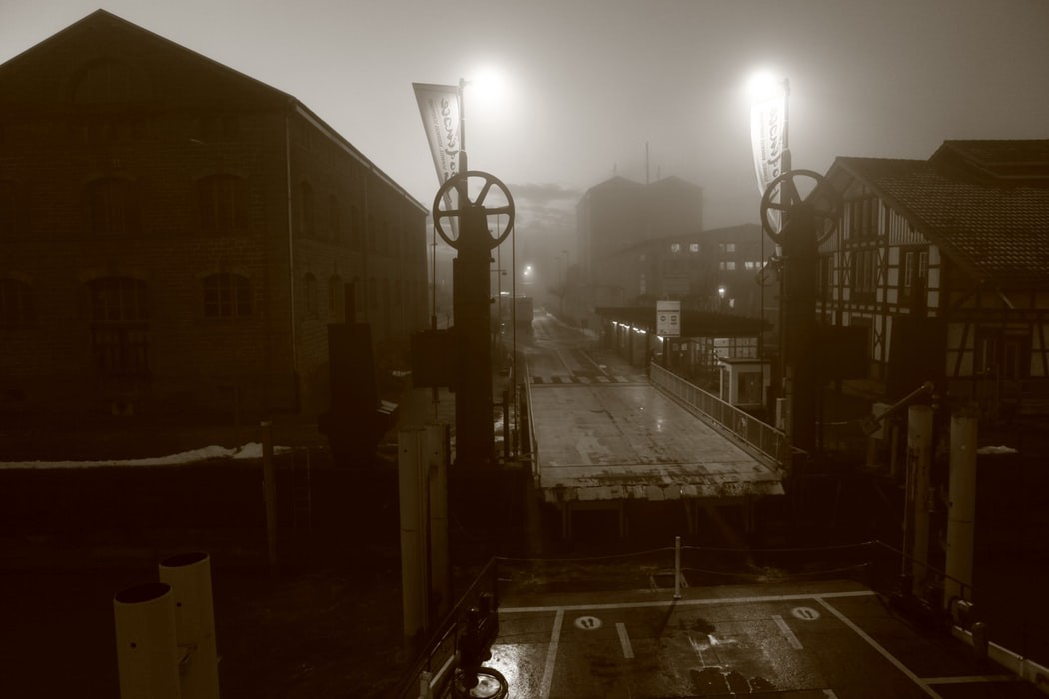

Child Labour
Workhouses/The new poor law
Education
Inventions & Innovation
Transport
Manufacturing
Imperialism/the slave trade

Introduction (Jarvis Faulks)
The Industrial Revolution was a major shift in Britain, the main causes are a combination of events and innovation and inventions that took place the late 18th and early 19th centuries, which are spread through a time of great upheaval in the life of the British people. The main features that took place include transport, steam machinery and wars or battles against enemies that opened the country to a new and dynamic era of prosperity, and led to new reforms in the social welfare of Great Britain.
During the time period of 1760-1840 there was a significant change to how the people of Britain lived and worked that would affect on how we live our lives today and it was called the Industrial Revolution.

The impact of the Industrial Revolution was ongoing and caused a major shift in the way people in Britain lived and learnt and earned their income. The use of steam and the desire to increase productivity, the changes were rapid and in many instances changed the way of life, especially for the poor.

Improvements in the speed of weaving during the eighteenth century were given impetus by the invention of spinning machinery for the production of yarn necessary for weaving. Until mechanical spinning came into use, the output of three to four spinners was necessary to keep one weaver fully employed. Acceptance of advances in loom technology was also aided by continuing improvements in spinning and cloth finishing technologies. The first significant move toward automated weaving occurred when John Kay invented the flying shuttle in 1733. The Flying Shuttle was set in motion by the weaver pulling a cord or handle that propelled the shuttle across the width of the textile. Not only did this speed weaving by as much as four times, it also allowed a weaver to produce cloth wider than his arm's reach.
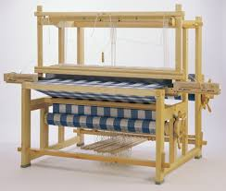
Ref: https://www.encyclopedia.com/fashion/encyclopedias-almanacs-transcripts-and-maps/weaving-machinery

I will talk about Education and Transport

Education

In particular the agricultural labourers that were at that almost completely illiterate suddenly needed to learn to read and write. The upper classes and clergy were against this because they feared the workers would gain knowledge. Before 1870, elementary education was provided largely by the Church of England, but most schools catered only for the rich you had to pay for education at that time.

“Almost all poor children had no education. Could not afford to go to school, because school wasn't free. Majority of the population were poor, so the country was not as well educated since only the wealthy could afford schooling. Most poor children had the jobs in factories, instead of getting an education.”

Ref: Education in England: a history Derek Gillard http://www.educationengland.org.uk/history/chapter06.html

At that time there was no middle class just upper and lower. In the wealthy houses the ladies often taught the children and they were just living as housekeepers and managing the home whilst the husband went to work, as a consequence the women did not have a vote; were considered inferior and often only had menial jobs like working in shops, sewing and other non important jobs if they were not housewives at home. In fact even up to World War II the women did very little manual work but during that war they were needed in factories making ammunition, so it was not till the 1940’s that life for women changed dramatically.
A school in the industrial revolution
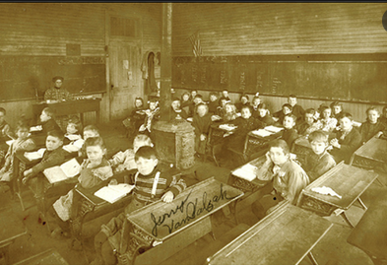

So in the industrial revolution the women saw and opportunity to find a career path through education and even today we find most schools have more female teachers than male. The industrial revolution therefore started to offer women a place in society, however the people of the day resisted the school idea and tried to get only the rich to go to school, but then free education was provided for all children. An act of parliament in 1883 made schooling a necessity and free.

“1833 The Government made it compulsory to have at least 2 hours of education per day for children who worked in factories. 1844 A union in Britain named: The Ragged Schools Union was created to give very poor children a chance to go to school.”
Ref: https://industrialrevolutiongroupbuddies.weebly.com/education.html

​“Education changed during the Industrial revolution. In the beginning (before the 1800’s) poor children couldn't afford the price to go the school, as school were not yet free in Britain. But then slowly school became compulsory, and poorer classed children could go to school, and many Acts and Unions took part in sponsoring and improving the schools in Britain. It changed the entire country because the country had more schooled children, and adults to work in better jobs and create better lives for the people in the next generation.”
ref https://industrialrevolutiongroupbuddies.weebly.com/education.html

The women now found a secure and rewarding life as teachers and with compulsory education they became more important in society.

Workhouse & the Poor affecting Education
As a consequence factories need more workers so with higher wages they attracted people from the land to towns and cities. Most farm workers were born, lived, worked, never left and died in their village and were in the most illiterate. But as the people moved to industry in the factories, many laborer’s were migrating to the cities. They needed housing and many back to back cheap houses were built to accommodate them, known as slums or better known as the Cottage industries which developed in cities around 1870, resulting in the harsh tenement housing system. Immigrant, illiterate families lived and worked in these crowded, unsafe apartment buildings. They worked for extremely low wages, usually making garments but needed to learn to read to manage machinery, and although men were encouraged to read the children were next to be considered, when the act was passed through parliament.
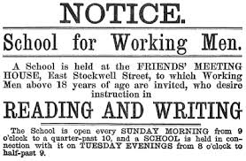
Children in particular were used in factories because they could climb under machinery to repair it and because they were paid a pittance, subsequently the poor evolved they ended up working in workhouses in slave like conditions. At a time when the government was trying to abolish slavery it was occurring at the cities and towns in their own country.

A workhouse school as portrayed by the employers
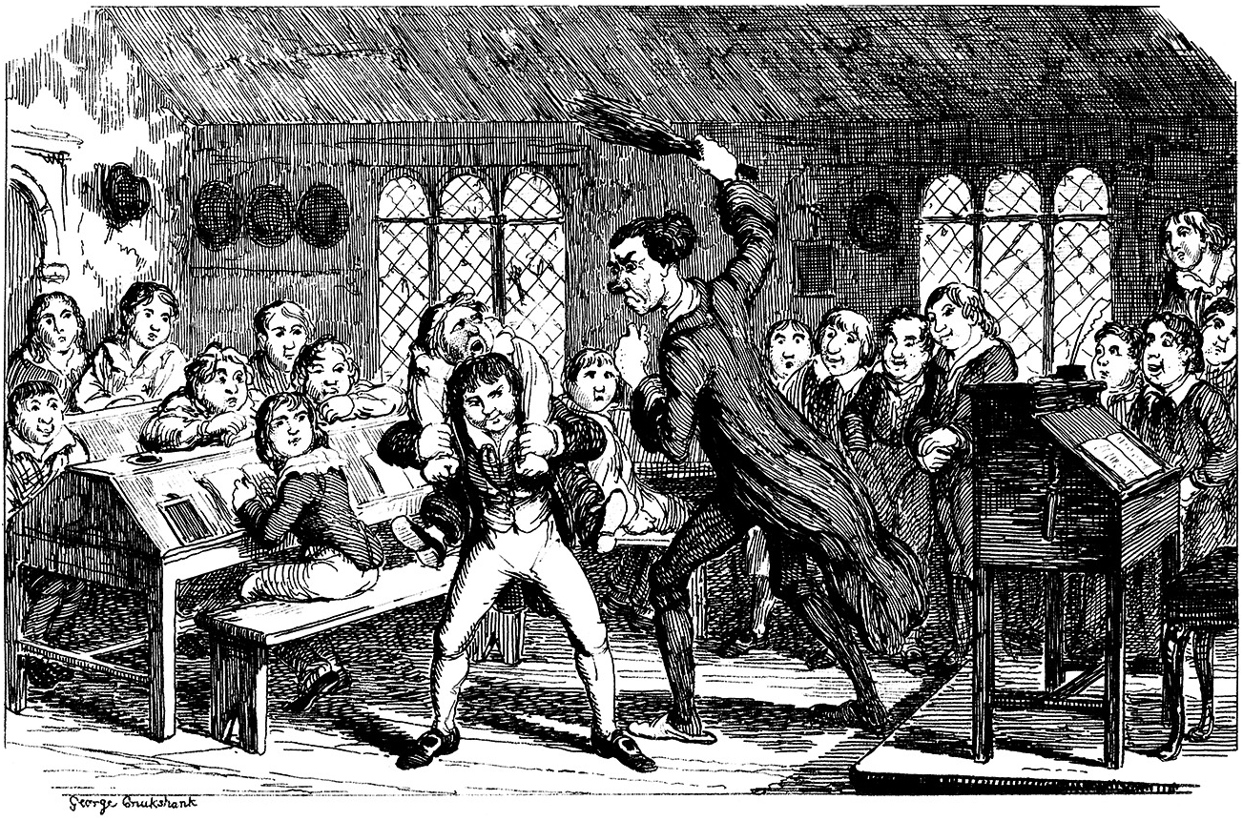
Ref: https://www.cambridge.org/core/books/abs/childhood-in-modern-europe/work-versus-school-during-the-industrial-revolution/75CB959D45089BF65D73B63FB8BB34C5

I believe that the industrial revolution was also a revolution for children and also for women particularly in the field of education and teaching.

Transport
The improvement needed in transport was required to move goods around the country, the pathways, “roads”, tracks and pot holed, often muddy connections between towns were pathetic, slow and uncomfortable. Stagecoach travel, walking or horseback were the only methods of moving from village to village, town to town or to city to cities.

Something was needed to improve the method of land travel. “Queen Mary Tudor” had passed a law making parishes responsible for roads, and each was expected to use labor, which workers were obliged to offer, for free six days a year, landowners were expected to offer the materials and equipment. Unfortunately, the workers were not specialized and often didn’t know what to do when they got there, and with no pay, there wasn’t much incentive to really try. The result was a poor network with much regional variation.”
Ref: https://www.thoughtco.com/development-of-roads-the-industrial-revolution-1221647

In the 1750's poor built roads were improved using the Metcalf system: "In order to deal with marshy areas he devised a method of laying heather and gorse as the foundation and building the road on top. This proved very successful and in many places enabled a more direct route to be taken.” Especially over marshy or sodden roads.
Ref: https://spartacus-educational.com/John_Metcalf.htm

A Scot called Thomas Telford (1757-1835) turned from being a successful stone mason and official Surveyor of Public Works for the County of Salop to building roads and bridges. He used a foundation of carefully cut stone blocks with a gravel surface on top.

Then John Loudon Macadam (1756-1836) developed his method of road building, “by adding a top surface of sand and small stones and rolling this down hard he produced a semi waterproof surface that would drain into the ditches. This approach, omitting the sturdy foundation, was cheaper if less robust than Telford's design and after some testing in 1827 the Government commissioned Macadam to build roads all over the country. The spread of 'Macadamised' roads heralded the beginning of the stage-coach era in which road journey times between cities were dramatically reduced and standards of comfort improved.
Ref: https://www.igg.org.uk/gansg/00-app1/roads.htm

Then Macadam developed a covering surface which eventually became known as tarmac and travel by road eventually became much better However another accidental occurrence helped this event.

Tarmac - Tar barrows, bucket and boiler
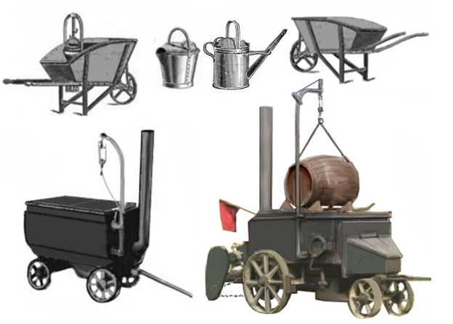
Tarmac the accidental road coating…
In 1901 a barrel of gas works tar fell off a lorry outside an iron works near Nottingham and split open on the macadamised road. The workers at the works threw powdery slag over the mess, some time later the local surveyor, one Edgar Purnell Hooley, noticed that the section of road had not deteriorated. Mr. Hooley conducted some experiments and found the best method was to pre-mix small stones with gas works tar, laying this on the road and adding more small stones on top. In 1902 he obtained a patent on the method and set up in business as the TarMacadam Syndicate Limited. The product worked and Mr. Hooley did well for a few years but then ran into financial problems. The TarMacadam road was evidently a winner and Sir Alfred Hickman, who owned a steel works and had a lot of slag to dispose of, purchased the rights from Hooley in 1905, changing the name of the firm to Tarmac.

Almost every road that we travel today is covered with Tarmac!

Using turnpikes to help cover the costs, meant that road travel could be expensive. However the movement of large quantities of goods was eased when Britain established a pathway of canals using barges to transport coal and goods.

Canal System (Only in Britain)
The UK was the first country to develop a nationwide canal network which, at its peak, expanded to nearly 4,000 miles (6,400 kilometers) in length. The canals allowed raw materials to be transported to a place of manufacture, and finished goods to be transported to consumers, more quickly and cheaply than by a land based route.
ref https://en.wikipedia.org/wiki/History_of_the_British_canal_system
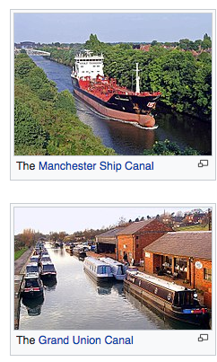
At last large goods could be moved around the country, using a system of locks the barges that could get to most major towns up or down through the invention of a locks system, although at quite a slow time frame, they could at least move huge amounts of goods like coal.

“The canals caused a great change in the economy of Britain. They supported the industries that allowed the country to become the world's first industrial power and created the wealth that led to the British Empire in the Victorian Era. The canals were built because they offered the most economic and reliable way to transport goods and commodities in large quantities.”
Ref: https://en.wikipedia.org/wiki/History_of_the_British_canal_system

Canals had more impact on internal transportation by utilizing existing infrastructure because the canal system had been in existence for many years prior to steam, the difference was in speed and expansion of destinations.

“Canals allowed a greater volume of goods to be moved more precisely, and for much less, opening up new markets in terms of location and affordability.”

Rail & Steam improve transport

By the 1850’s the railway system had become well established, and the amount of cargo carried on the canals had fallen by nearly two-thirds, lost mostly to railway competition.

About the Rocket - Robert Stephenson
The Rocket was built to run on the Liverpool and Manchester Railway, the world's first inter-city passenger railway line. In 1829, Rocket won the Rainhill Trials, which was a competition to decide on the best mode of transport for the railway.
Rocket was the only locomotive to successfully complete the trials, averaging 12 mph and achieving a top speed of 30 mph. Designed by Robert Stephenson, Rocket's win proved once and for all that locomotives were better at pulling trains along the Liverpool and Manchester Railway, rather than stationary winding engines.
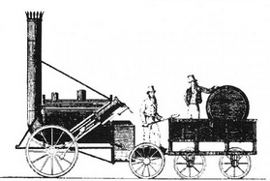
So along came steam and Robert Stephenson Rocket train, established that rail was faster than canals, and thousands of labourers built railway tracks all over Britain so transport was now in full swing, fast efficient and reliable. With the advent of steam the manufacturing factories also developed new machines like the Spinning Jenny and textile weaving machines and sewing machines. The agricultural side also benefitted with development of steam tractors and farm equipment.

But the improvements in transport and better education led to Britain becoming the greatest nation in the 1800’s

Jarvis Faulks

End of Essay

